MODA
MOdelling DAta providing a description
for the Half-Cell User Case
simulated in project NanoBat

OVERVIEW of the SIMULATION
1 | User Case | A coaxial tip, as extruded from a coax line, is placed above the sample-under-test (SUT) of a battery-relevant material (MUT - material-under-test). The tip is electrically excited through the coax, which itself is excited by a vector network analyser (VNA). Information about the MUT is obtained either from electric field distribution or from the signal reflected by MUT and measured by the VNA.  Our MUT will, typically, be a graphene (anode) deposited on copper or a SEI (solid electrolyte interface) formed on the graphene anode due to electrolyte decomposition during the battery formation/operation.
2 | Chain of Models | Model 1 | Continuum Modelling of Materials: Electromagnetic Model (Maxwell Equations), reduced to Quasi-Electro-Statics at DC limit
 |  | Model 2 | Continuum Modelling of Materials: Transport in Diluted Species (Nernst-Plank-Poisson or Nernst-Plank Equations)
3 | Publication Peer-Reviewing the data | To be filled at the later stage of the project.  [Please give the publication which documents the data of this ONE simulation.  This article should ensure the quality of this data set (and not only the quality of the models).]
4 | Access conditions | Three groups of the WP3 will be involved in this task. JKU will apply COMSOL commercial FEM-based solvers. QWED will use their own FDTD commercial solver.  Part of the models and simulated results will be free.  The GUI and representative software versions dedicated to teaching and dissemination will be free (open access, but not open source).  Open Platform created in the NanoBat project (https://www.nanobat.eu/) will provide access to:  - the Models (CAD data files and results in Gwyddion format),  - Open GUI needed for examining and modifying the models as well as for visualising and analysing the computed results,  - dedicated FDTD solvers suitable for teaching and dissemination of major project results concerning the Models.  Commercial vendors should be contacted for full-power versions of FEM and FDTD solvers.
5 | Workflow and its rationale | The chosen user case is a typical experimental arrangement relevant for the study of nanoscale material and electrochemical effects in energy materials like Lithium-ion Battery (LIB).  Model 1: will be used to compute the electric field in the entire structure by solving Maxwell equations. The main numerical result of the simulation will be the E -field everywhere in the structure. The obtained E- and H-values will be integrated at the post-processing stage to obtain the S-parameter (S11) at the input.  Model 2: will couple the electric fields with the transport equation for electrochemical species and include equations for electrochemical reactions on the electrode surfaces.

User Case Parameters
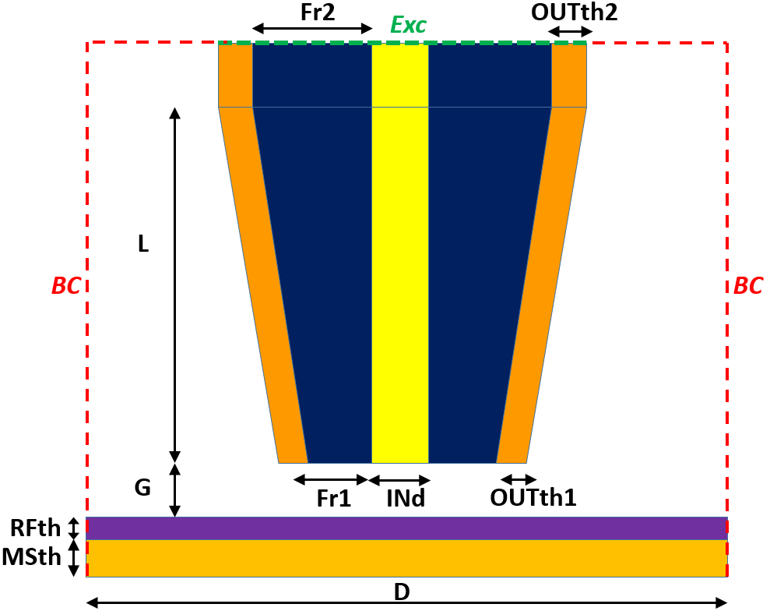
Fig. 1. Cross-section of the half-cell structure.

Table 1. Parameters of the half-cell User Case.
Parameter | Meaning | Value/values range | Comment
INd | Diameter of inner conductor | 100nm - 5μm
OUTth1 | Thickness of outer conductor at tip bottom | 100nm - 1μm
OUTth2 | Thickness of outer conductor at tip top | 100nm -
Fr1 | Radius of the tip dielectric filling at the tip bottom | 1μm-10 μm
Fr2 | Radius of the tip dielectric filling at the tip top | 100μm-500 μm
L | Length of the tip | 10 – 10000 μm
G | Gap between the tip and material sample | 1nm-100nm
RFth | Thickness of the resistive film | 5 – 50 nm | Porosity
MSth | Thickness of the metallic substrate | 1 mm | To be modelled as a boundary
D | Diameter of computational scenario | >Fr2+OUTth2+0.5INd | Subject to boundary conditions, typically mm – cm.
BC | Outer boundary condition | PEC (E tangential=0) or  PMC (H tangential=0)  or  ABC (absorbing / free space) | For quasistatic scenario fields this choice should be of minor importance, as fields are concentrated in the vicinity of the tip
medIN | Medium of the inner conductor | PEC
medOUT | Medium of the outer conductor | PEC
 |  | Metal with finite conductivity:  σ= 9.4 10⁶ S/m | Platinum
 |  | None
medF | Medium of the tip dielectric filling | Glass:  ε_{r}= 4.6 , tanδ= 0.002 | Borosilicate glass
medRF | Medium of the resistive film | Dielectric:  ε_{r}= 2-10,  σ= 10⁻⁴ - 10⁴ S/m
medMS | Medium of the metallic substrate | PEC
medE | Medium of the electrolyte | Dielectric constants: ε_{r}; tanδ.  diethyl carbonate (DEC)  ε_{r} = 2.82 [Wohlfarth, C. Permittivity (Dielectric Constants) of Liquids. In  CRC Handbook of Chemistry and Physics (Internet Version 2015)]  dimethyl carbonate (DMC)  ε_{r}= 3.08 [W. M., Ed.; CRC Press/Taylor and Francis: Boca Raton, FL,  2015; pp 6-187−6-208.]  ethyl methyl carbonate (EMC)  ε_{r} = 2.9 [McEwen, A. B. et. al; Electrochem. Soc. 1997,  144 (4)]  dimethoxyethane (DME)  ε_{r} = 7.2 [Ue, M, et. al.,  J.Electrochem. Soc. 1995, 142 (8), 2577−2581]  Note: Dielectric constant values are obtained at room temperature 25°C. | To be obtained from literature, if possible, some parameters compared to experiments. (Dielectric constant varies with temperature and concentration)
Problem type |  | BOR | One central hole (axisymmetric)
Excitation |  | TEM mode incident from a coaxial line, from which the tip is extruded  or  lumped voltage source between the inner and outer conductor at the upper end of the tip | These are standard port definitions in EM software
Freq | Frequency of analysis | DC to 10 GHz
Requested output |  | S11(f)  or  electric field distribution at selected frequencies

Workflow
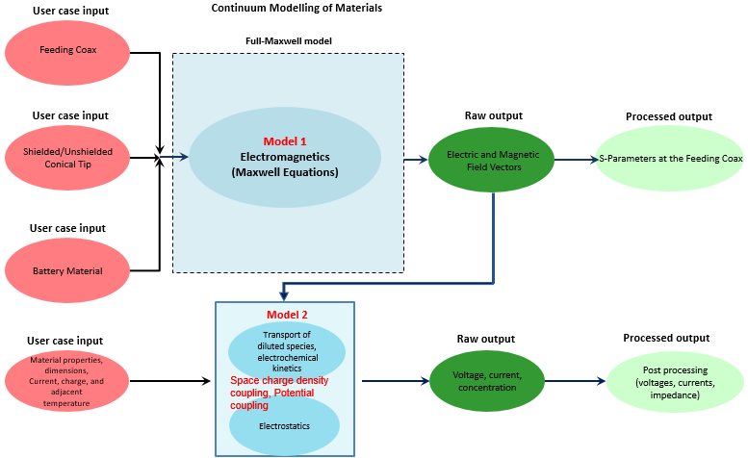

MODEL 1
Time domain (FDTD) and frequency domain (FEM) Electromagnetic Analysis
1 | Aspect of the User Case/System to be Simulated
1.1 | Aspect of the User Case to be simulated | Compute the E- field (and H- field for full-wave Maxwell) of the entire structure for a given excitation at the input port (the beginning of the extruded coaxial tip).
1.2 | Material | See figure and table for materials of the test fixture and environment  The MUT is a battery anode sample (e.g. graphite coated on copper) covered with electrolyte material used for Li-ion batteries (e.g. LiPF6), with/without SEI.
1.3 | Geometry | See figure and table
1.4 | Time Lapse | The chosen frequency range is DC to 10GHz. Depending on the goal of simulation several to 100 periods of the source signal at its lowest frequency are to be simulated.
1.5 | Manufacturing process or  in-service conditions | Material-under-test deposited on metallic background; coaxial tip extruded using the technologies of METAS.  unshielded tips made by JKU Linz.  Keysight VNA connected through a coax line to the top port of the coaxial tip  The electrical boundary conditions are PEC below the sample, free space around.
1.6 | Publication on this data | Several papers are foreseen at the later stage of the project.

2 | Generic Physics Of The Model Equation
2.0 | Model type and name | Continuum Modelling of Materials: Electromagnetics
2.1 | Model entity | Finite volumes (elements or cells)
2.2 | Model Physics/ Chemistry equation  PE | Equation | Maxwell equations (full-wave or in quasi-electro-static approximation)
 |  | Physical  quantities | Spatial coordinates (3 scalars), time (scalar), E-field, H-field (vectors), magnetic permeability, electric permittivity, electric conductivity (scalars or diagonal tensors).
2.3 | Materials relations | Relation | $\vec{D}=ε\vec{E}$, $\vec{B}=μ\vec{H}$, $\vec{J}=σ\vec{E}$
 |  | Physical quantities/  descriptors for each MR | The values $\left(μ,ε,σ\right)$ are obtained by own measurements or taken from the available literature.
2.4 | Simulated input | Simulated input is either a voltage applied or a guided wave launched at the top of the coaxial tip. The amplitude and the frequency of the wave is to be chosen by the user. For time-domain simulations a pulse covering the assumed spectrum can also be chosen as excitation.

3 | Solver and Computational translation of the specifications
3.1 | Numerical Solver | FDTD, FEM.
3.2 | Software tool | Comsol, QuickWave,
3.3 | Time step | Needed only for the TD solver of QWED, will be taken according to the stability condition.
3.4 | Computational Representation | Physics Equation, Material Relations, Material | no special computer representation - physical quantities directly modelled (scaled for convenience)
3.5 | Computational boundary conditions | The computational domain should be surrounded by a cylindrical boundary condition (PEC, PMC or ABC); bottom boundary in PEC; top is excitation region
3.6 | additional Solver Parameters | - FEM and FDTD: size of the computational box (D of figure) - chosen so as not to influence the simualted reuslt  - FDTD: Stability limit for the given mesh; time lapse to achieve converged computed result  - FEM: Convergence criteria.

4 | POST PROCESSING
4.1 | The processed output | The E-field (and H-field for full Maxwell) vectors in each element of the mesh are directly obtained. E-field is integrated to approximate local voltages. For full Maxwell, the fields at the input (upper port) are converted to S-parameters.
4.2 | Methodologies | FDTD (Discrete Fourier Transformation and S-parameters extraction) and FEM (frequency domain vector solution approach yielding directly the needed frequency characteristics)
4.3 | Margin Of Error | to be discussed in future publications

MODEL 2
Frequency domain (FEM) Electromagnetic Analysis coupled with transport equation for electrochemical species

1 | Aspect of the User Case/System to be Simulated
1.1 | Aspect of the User Case to be simulated | Chemical reactions computed as functions of concentrations of reactant species, while accounting for surface concentrations of active sites and surface adsorbed species. Transport of electrochemical species by diffusion/migration due to an electric field for a given excitation at the input port (the beginning of the extruded coaxial tip)  The electric fields are coupled with the transport equation at lower frequencies for electrochemical species, equations for electrochemical reactions on the electrode surfaces are considered.
1.2 | Material | See figure and table for materials of the test fixture and environment.  The MUT is a conductive sample (e.g. battery anode sample: graphite coated on copper) covered with electrolyte material used for Li-ion batteries (e.g. LiPF6)
1.3 | Geometry | See figure and table above
1.4 | Time Lapse | Considering a characteristic frequency range from DC to 1 MHz and depending on the aim of simulation several periods of the source signal at its lowest frequency are to be simulated. For example, time lapse can be from a few seconds up to 1 hour.
1.5 | Manufacturing process or  in-service conditions | Material-under-test deposited on metallic background; coaxial tip extruded using the technologies of METAS /RUB/ JKU.  Keysight VNA connected through a coax line to the top port of the coaxial tip.  In service boundary conditions: The electrical boundary conditions are PEC below the sample, free space around.  Ambient temperature
1.6 | Publication on this data | Targeted publication/s during the project e.g. Physical Chemistry Chemical Physics: PCCP 2017, 19, 3884-3893

2 | Generic Physics Of The Model Equation
2.0 | Model type and name | Continuum Modelling of Materials: Electrostatics, Transport of diluted species, electrochemistry
2.1 | Model entity | Finite volumes (elements or cells)
2.2 | Model Physics/ Chemistry equation  PE | Equation | Charge conservation dynamic  Nernst-Plank-Poisson Equation (diffusion, concentration)  Nernst-Einstein relation (mobility)  Gauss law, Faraday’s law
 |  | Physical  quantities | Spatial coordinates (3 scalars), displacement (scalar), time (scalar), E-field, electric permittivity, electric conductivity (scalars or diagonal tensors), diffusion (scalar), concentration (scalar)
2.3 | Materials relations | Relation | Charge conservation  $E=-∇V$  $∇∙\left(ε_{0}ε_{r}E\right)=ρ_{v}$  $D=ε_{0}ε_{r}E$  Surface charge density  $n∙\left(D_{1}-D_{2}\right)=ρ_{s}$  Transport properties  $∇∙J_{i}=R_{i}$  $J_{i}=-D_{i}∇c_{i}-z_{i}u_{m,i}Fc_{i}∇V$  $u_{m,i}=\frac{D_{i}}{RT}$  Space charge density coupling  $∇∙D=ρ_{v}$  $ρ_{v}=F\sum_{i}{z_{i}c_{i}}$  Electrode surface reaction  Reaction coefficients  $R_{i}=\frac{V_{i}i_{Ioc}}{nF} \sum_{ox}{\left|v_{ox}\right|Ox+ne^{-} ↔\sum_{red}{v_{red}Red}, v_{red}>0}$  $\frac{∂c}{∂t}+∇∙\left(-D_{s}∇c+cu\right)=0$  where $D_{s}$ denotes the diffusivity of the reacting species, $c$ is its concentration, and $u$ is the velocity.)  Boundary conditions:  Zero charge boundary  $n∙D=0$  Terminal voltage boundary  $V=V_{0}$  Ground boundary  $V=0$  No Flux boundary  $-n∙J_{i}=0$  Initial concentration values  $c=(x.x) mol/m^{3}$  $ci=(x.x) mol/m^{3}$  Symbols definitions:  Electric field density: $E$ (V/m)  Current density: $J_{i}$ (A/m²)  Electric charge density: $ρ$ (C/m³)  Electric displacement: D (C/m²)  Electric potential: V (V)  Solvent velocity field: u (m/s)  Ionic mobility: $u_{m,i}$ (mol.s/kg)  Production/consumption rate expression: $R_{i}$ (mol/m³.s)  Concentration of species i : $c_{i}$ (mol/m³)  Permittivity: 𝜀 (F/m)  Relative permittivity: 𝜀_{r}  Gas constant: R (J/(mol.K))  Temperature: T (K)  Diffusion coefficients: $D_{i}$ (m²/s)  Faraday’s constant: F (A.s/mol)  Capacitance: C (F)  Normal vector to surface: n  Charge number: z (unitless)  Note: bold symbols are vectors.
 |  | Physical quantities/  descriptors for each MR | The values $\left(μ,ε,σ\right)$ are obtained by own measurements or obtained from available literature.  Concentration  Displacement  Temperature  Charge
2.4 | Simulated input | Simulated input is either a voltage applied, or a guided wave launched at the top of the coaxial tip. The amplitude and the frequency of the wave is to be chosen by the user. For time-domain simulations a pulse covering the assumed spectrum can also be chosen as excitation.

3 | Solver and Computational translation of the specifications
3.1 | Numerical Solver | Finite Element Method (FEM).
3.2 | Software tool | Comsol
3.3 | Frequency step | DC up to GHz. Logarithmic stepping applied.
3.4 | Computational Representation | Physics Equation, Material Relations, Material | no special computer representation - physical quantities directly modelled (scaled for convenience)
3.5 | Computational boundary conditions | The computational domain should be surrounded by a cylindrical boundary condition (PEC, PMC or ABC); bottom boundary in PEC; top is excitation region.  Terminal voltage, ground and initial concentrations.
3.6 | additional Solver Parameters | - FEM: size of the computational box (D of figure) - chosen so as not to influence the simualted result  - FEM: Convergence criteria.

4 | POST PROCESSING
4.1 | The processed output | Terminal current is used to calculate the tip sample impedance.
4.2 | Methodologies | FEM (frequency domain vector solution approach yielding directly the needed frequency characteristics)
4.3 | Margin Of Error | to be discussed in future publications. Depending on truncation error, system size and thresholding for convergence.

